**ECOMMERCE WEBSITE**

**BUGS:**

* While we are place the products in Add to cart the same product should be added in a one-by-one order

Example: when we placed the Samsung 5G phone in Add to cart it should be add as follows:

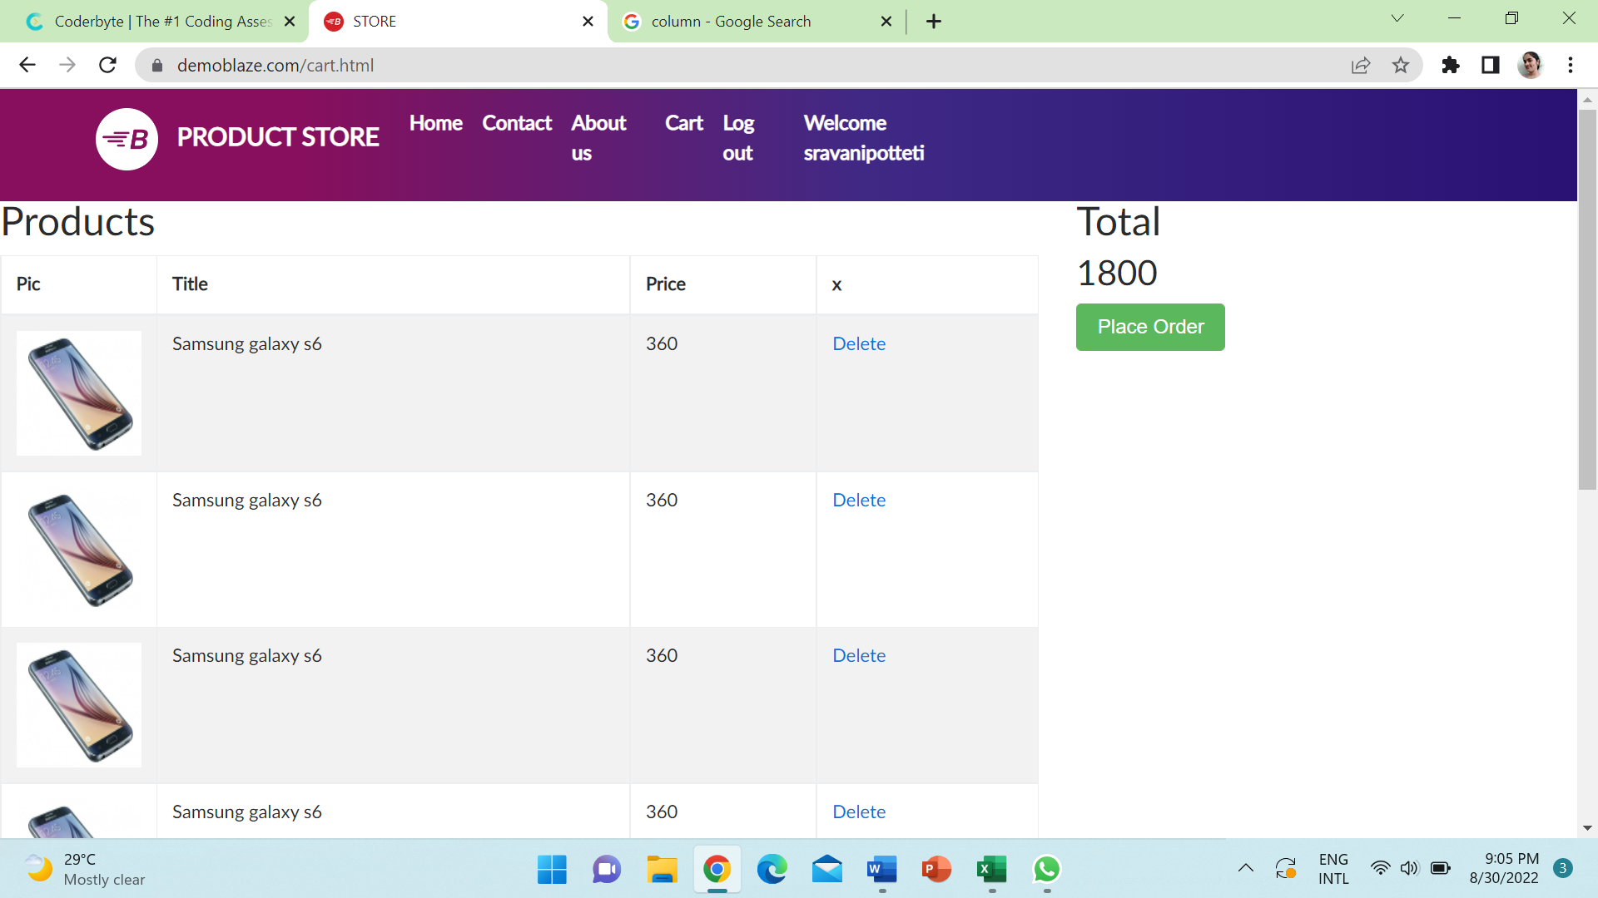

**IMPROVEMENTS:**

* We will place the reviews for the products on Website so, it will be helpful for the customers to buy the products trustfully and happily.
* After placing the order, we will add some additional details like phone number or email id to confirm the order.
* We also add on some additional information like cash on deliver, Online Transactions like phone pay/Google pay/Paytm these are more helpful for the customers to buy the products easily.